**7. Implementation of Intrusion and Detection System Aim :** To implement IDS system using **snort tool** in Ubuntu OS environment. **Procedure**

1. Log on to **goorm.io** IDE
2. Create a new container for Ubuntu operating system(**Ubuntu 18.04 TLS**) and run the container.
3. Select terminal window by pressing **Alt+Shift+T** or select **New Terminal window**

option from **Window** menu.

1. Trace the IP address of our network using **ifconfig** command(**#ifconfig**)
2. Install the text editor **‘nano’** by typing the following command in prompt

# #apt-get install nano

1. Install the **snort** tool by typing the following command in prompt.

# #apt-get install snort

1. Go to **/etc/snort** directory (**#cd /ect/snort**)
2. Open **snort.conf** file using **nano** editor(**#nano snort.conf**).
3. Update the **snort.conf** file to implement IDS

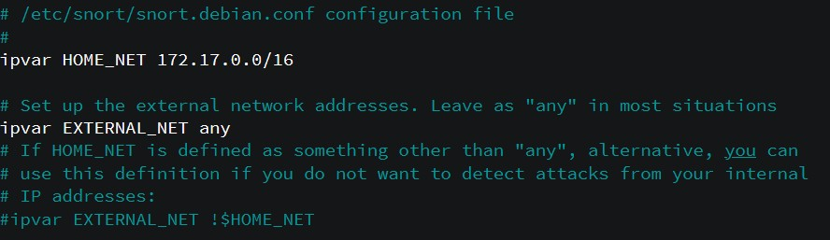

1. Save and Exit from **nano** editor(**Ctrl+O and Ctrl+X**)

# Go to /etc/snort/rules directory (#cd /ect/snort/rules)

1. Update the **local.rules** files using nano editor (#**nano local.rules**)

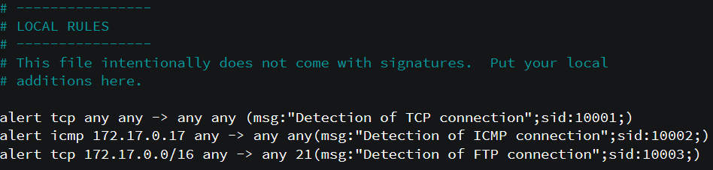

1. Save and Exit from nano editor(**Ctrl+O and Ctrl+X**)
2. Run the IDS system snort

# #snort -T -c /etc/snort/snort.conf

**#snort –A console -c /etc/snort/snort.conf**

1. verify the IDS system from external network.

# #apt-get install nmap #ping 172.17.0.17